- So I thought that roughly speaking, the first half mini report is about how we chose our NLP model. Which in my mind would go just as a link “see appendix 4a for explanation of how the model was justified” at the beginning of how you address the business question “Has the sentiment of central bank speeches changed over time? If so, how has it changed?”
- Then the second half, of this repot here the word clouds etc. might fit in regarding the business question “Do these speeches have any predictive power to assist in predicting market behaviour?”
- So it would just be please see appendix 4d for a basic overview of which words contribute to whichsentiment in speeches, 4e for FSR reports and 4f for MPC reports.

Natural Language Processing introduction
In this section of the report, we assess both general-purpose and finance-specific natural language processing (NLP) tools, considering their methodological fit, domain specificity, and performance in capturing the subtleties of financial language.

Why should NLP matter to The Bank of England?
From The Bank itself, “Central banks, like other policymakers and possibly more so, have to communicate complex messages to different audiences with different degrees of informedness. For instance, they must communicate to financial markets as well as, increasingly, to the general public. The importance of effective communication has grown in recent years, as communication has increasingly become a key tool in the central bank policy shed. ”
Advantages of NLP:
- Enhanced Scalability: NLP allows for the processing of large datasets, like the one provided to us, swiftly and efficiently.
- Consistency in Analysis: NLP provides a standard method for text analysis, which brings uniformity to the interpretation of financial communications, removing individual variability that often affects human analysis.
- Quantitative Insight: By converting qualitative data into quantitative outputs, NLP facilitates allows for statistical analysis of sentiment trends.
limitations of NLP:
- Contextual Nuances: NLP systems currently struggle with complexities of language that involve context, subtext, or cultural nuances, particularly in the specific language used in finance; a problem the models will encounter frequently.
- Data Dependency: The accuracy and reliability of NLP models are contingent upon the quality and diversity of their training datasets. Inherent biases in these datasets can lead to misinterpretations and analytical errors.
- Adaptability to New Terminologies: The financial sector frequently introduces new concepts and terms. NLP systems require continuous updates to incorporate such changes.
Throughout the entire NLP section of the report the “expected neutrality of a central bank communication” is often referenced. While there are multiple sources that provide reasonable backing for this statement, here is a particularly useful summary of the consequences of not maintaining an expected neutrality; “Indeed, markets and external actors might adapt and respond in advance to central bank decisions if the central bank became totally transparent, freely expressing its preferences and decision-making processes. This might jeopardise the central bank’s capacity to achieve its goals since market expectations can impact economic actors’ behaviour and change the expected outcomes of monetary policy.”

Outlining the NLP models

The Bank of England provided a file called “BankSpeeches_StarterCode” which provides a preliminary overview. The key takeaway from this document is that two NLP models, Vader and TextBlob, are mentioned. As such these will be our general-purpose sentiment models.
Also provided by The Bank is the Loughran McDonald(“lm” in the Notebooks) financial lexicon, so this will be our first financial specific model. Our second financial model, after discussion from the team, will be FinBERT from Hugging Face. We are excited to employ Google’s BERT on the speech data as it uses a considerably more advanced approach to hopefully offer a more sophisticated contextual analysis.
These four potential models should give us a nice spread of sentiment scores to analyse and deliberate over. Useful too that a finance model Loughran McDonald and a general model TextBlob both have a dictionary-based approach allowing us to compare dictionary methods to the more advanced Vader and FinBERT.

The subsequent findings will guide the selection of an optimal model for future analytical tasks within financial sentiment analysis.

All charts and plots can be found in the accompanying Notebooks.

General sentiment analysis tools:

TextBlob
“TextBlob is a Python library for processing textual data. It provides a simple API for diving into common natural language processing (NLP) tasks such as part-of-speech tagging, noun phrase extraction, sentiment analysis, classification, and more.”
- TextBlob uses a dictionary-based approach for sentiment analysis, relying on part-of-speech tagging and noun phrase extraction to interpret the sentiment of textual data. This method provides the user with a simple and transparent approach to sentiment analysis.
- TextBlob can be loaded into a python environment for use.

Vader
“VADER Sentiment Analysis. VADER (Valence Aware Dictionary and sEntiment Reasoner) is a lexicon and rule-based sentiment analysis tool that is specifically attuned to sentiments expressed in social media and works well on texts from other domains.”
- Vader combines a dictionary-based approach with a set of grammatical and syntactical rules. This approach allows VADER to capture both the lexical content and the contextual nuances of language used in social media and other text types.
- With regards to the speech data, Vader has the opportunity to offer a more nuanced insight into semantic scores with its ability to better understand sentiment contexts.
- TextBlob can be loaded into a python environment for use.

Both of these models are more general sentiment analysis tools and might provide an interesting, generalised view of the speech data but they might lack domain specificity. As such, let us now explore Loughran McDonald and FinBERT.

Financial sentiment analysis tools:
Loughran McDonald
Loughran McDonald is similar to TextBlob in the approach to sentiment analysis, however, Loughran McDonald offers the financial domain specifics where TextBlob does not. “They analyzed over 40,000 10-Ks from 1994-2007. Within these financial documents, they scored individual words across different categories of sentiment ”
- Loughran McDonald is provided as a large .csv file from The Bank. So, it warrants further discussion as how we implement it best. This can be found at the end of the NLP section titled “Further consideration for Loughran McDonald implementation”
FinBERT
“FinBERT is a pre-trained NLP model to analyze sentiment of financial text. It is built by further training the BERT language model in the finance domain, using a large financial corpus and thereby fine-tuning it for financial sentiment classification.”
- In the same way that TextBlob and Loughran McDonald have a similar approach, Vader and FinBERT also share similarities that extend beyond a simple dictionary usage.
- Like Vader, FinBERT offers a more comprehensive and nuanced understanding of sentiment by considering context. Unlike Vader, FinBERT uses Google’s BERT to leverage the advanced deep learning architecture of BERT to provide a more nuanced understanding of sentiment,
- FinBERT can be loaded into a python environment for use.

Model performance
Ideally we would want to choose one general sentiment analysis tool and one more financial specific sentiment analysis tool. This way we might be able to see if there is a difference between general sentiment scores to financial ones.

Comparison of general sentiment analysis tools:
TextBlob
TextBlob had the most rigorous normalisation of all the models:
- Ensure text is clean (Remove noise): Remove noise such as URLs, HTML tags, hashtags, mentions (if we don't believe it would contribute to sentiment). From the above, we have decided to keep hashtags and mentioned, but removed URLs
- Ensure text is clean (Handle missing values): Also ensure there are no missing values. We have completed this step above.
- Language: TextBlob primarily supports English out of the box. We have identified which speeches are in English.
- Text preprocessing (Lowercase): Processed below.
- Text preprocessing (Remove Stopwords): Processed below
- Text preprocessing (Lemmatisation): Lemmatisation was not done at this stage (it is also optional), as we have received a sentiment labelled wordlist from BoE where the reference text has not been lemmatized.
The speech data is loaded and TextBlob run through the data to acquire sentiment.
Here is the distribution of the TextBlob sentiment across all speeches. The histogram allows for an immediate visual interpretation of the data:
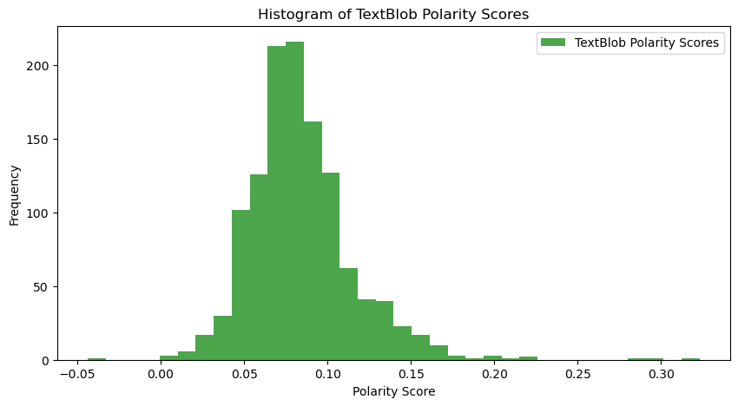
- This is a healthy shaped curve but shows a surprisingly small spread across the sentiment range with the vast majority of speeches clustered around 0.1 on the sentiment scale.
- There are two ways to interpret this:
  - We could be seeing representative use of formal, cautious, and neutral language that The Bank of England might use.
  - Or this spread is a result of TextBlob's general-purpose model not grasping economic jargon and financial context. The extreme nature of the histogram suggests that this is more likely.
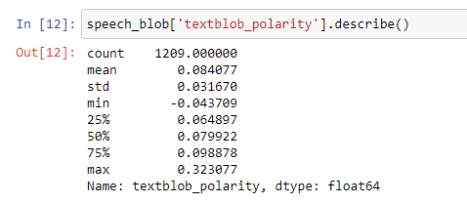
The descriptive statistics suggest:
- Mean: The mean sentiment score is 0.084077, suggesting a generally neutral sentiment across the dataset, with a slight positive lean.
- Standard Deviation: The standard deviation is 0.031670, which is relatively small, indicating that the sentiment scores do not vary widely and tend to be close to the mean.
- Minimum: The lowest polarity score is -0.043709, showing that the most negative sentiment is only slightly below neutral.
- 25th Percentile: 25% of the scores are below 0.064897. Since this is above zero, it suggests that the lower quartile of data still leans towards the positive sentiment.
- Median (50th Percentile): The median score is 0.079922, which is close to the mean, further indicating a very slight positive sentiment trend.
- 75th Percentile: 75% of the scores are below 0.098878, and being above the median, this suggests that the upper quartile of the scores is more strongly positive but still fairly neutral.
- Maximum: The highest polarity score is 0.323077, which indicates the presence of some positive sentiments but nothing extremely positive.

Vader
Vader is designed for social media text and requires less normalisation than TextBlob. Its built-in appreciation for nuances in the language, such as capitalisation and punctuation, enables it to interpret emphasis and sentiment with little preprocessing. The normalization steps we applied to Vader included:
- Ensure text is in English : We have tagged each speech for their language.
- Handle missing values: That has been completed in the previous cleaning steps.
- Standardise text data : Vader works well if the text is standardised (i.e. ensure consistent use of quotation marks etc). We will take the assumption that the use of quotation marks etc has been applied consistently.
- Remove unnecessary elements: It is good practice to remove URLs and other specific mark ups. However, in the same vein, it is important not to over clean. As seen above, we have kept hashtags and mentions as they appeared to be important in providing context to the speeches, however URLs have been removed.
- Ensure Data is in a Suitable Format: The data is contained in a dataframe column.
The speech data is loaded and Vader run through the data to acquire sentiment.
Here is the distribution of the Vader sentiment across all speeches. The histogram allows for an immediate visual interpretation of the data:
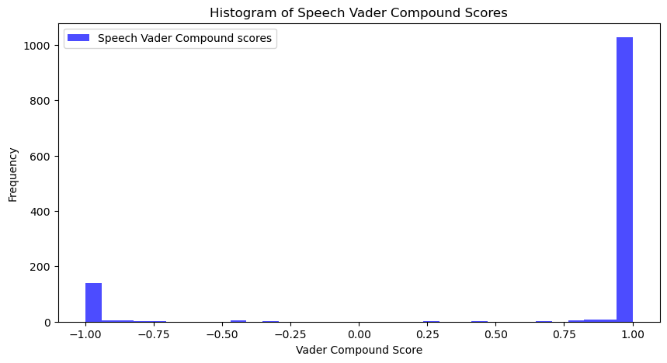
- Considerably different distribution of sentiment scores to TextBlob, Vader almost seems to be binary but for the occasional rise near -05 and near 0.8 .
- This is unlikely to reflect how the Bank of England chooses the tone of its speeches so we have to assume again that Vader’s more generalised lexicon is not appropriate for more financial contexts.
- Since Vader is particularly useful at analysing language like social media, Vader’s method of analysing intensity might be picking up on the presence of strong financial jargon and interpreting it as carrying more sentiment weight than intended.
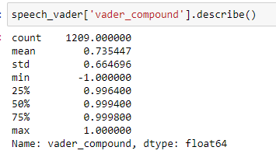
The descriptive statistics suggest:
- Mean: The average sentiment score is very high (0.735447), indicating an extremely positive sentiment across the dataset.
- Standard Deviation: The standard deviation is significant too (0.664696), suggesting a wide range of sentiment scores from highly negative to highly positive.
- Minimum: The lowest sentiment score is -1.000000, indicating the presence of extremely negative sentiments in some instances.
- 25th Percentile: This value is very high (0.996400), which is unusual for sentiment scores and suggests that 25% of the data has very high positive scores, just below the maximum.
- Median (50th Percentile): The median is 0.999400, extremely close to the maximum, again showing a very strong positive sentiment within the dataset.
- 75th Percentile: With 75% of scores below 0.999800, we see that the vast majority of the dataset skews towards the maximum positive score.
- Maximum: The highest sentiment score is 1.000000, the highest possible score, indicating extremely positive sentiments.

If we compare both tools to each other through a time-series analysis of the sentiment scores, averaged annually (mean), it neatly reveals the limited variability with TextBlob and more pronounced fluctuations with VADER.
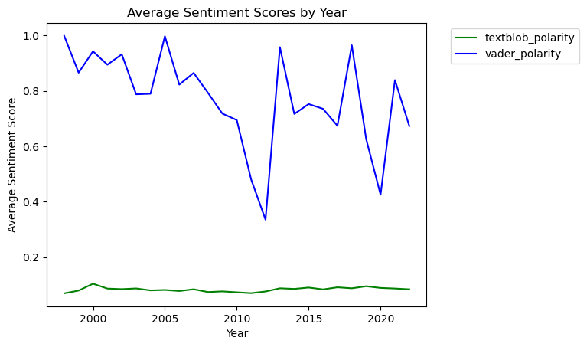
Increasing the granularity and breaking down the data quarterly, the variance in VADER's scores becomes more evident, revealing the model's probable over-sensitivity to financial terminology and its tendency to produce extreme sentiment values. This original chart can be viewed in the Notebook for better accessibility, this chart is for illustrative purposes only.
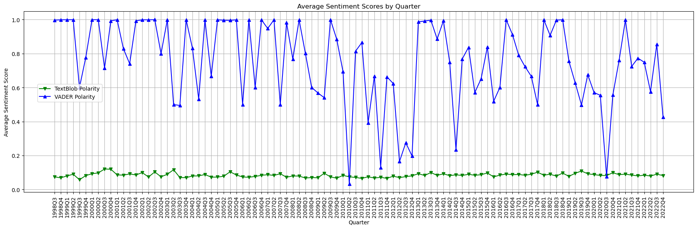
- Vader’s sharp peaks and troughs start to show the model’s weakness and lack of usability here. We begin to see the earlier distribution that almost looked binary become displayed.
- Further granularity of time data of this time series chart revealed the extend of Vader’s movements across the polarity scale.
With each further level of granularity Vader becomes more and more exaggerated, to the point where it is not possible to assume that The Bank of England would deliver such bipolar communications.
- Should you wish to view this data at a daily level this plot can be explored in an interactive Plotly chart in the Notebook attached.
In conclusion, it became apparent that general-purpose NLP models were not adequately aligned with the specific requirements of financial language. Given these observations, the decision was made to concentrate our analytical efforts on finance-specific models like Loughran McDonald and FinBERT. This approach was underpinned by the premise that models tailored to the financial domain would inherently offer more insightful and accurate sentiment assessments.

Comparison of financial sentiment analysis tools:
Loughran McDonald
We received a custom word list to help with our sentiment analysis of financial terms. This document, “LSE_DA_BoE_Employer_project_Sentiment-labelled_wordlist.xlsx,” was provided as part of the core dataset by The Bank of England.
Upon reviewing the document, it was found that the main the sheet is labelled “Loughran-McDonald_MasterDiction,” pointing us towards a financial lexicon free for use in academic research.

Composition:
Loughran McDonald is formed of two parts:
- The base dictionary is release 4.0 of 2of12inf. “This is a fairly common baseline dictionary and is oriented towards common words.”
- The financial base is specifically targeting the 10-K filings and earnings calls, specifically “EDGAR 10-K archive and earnings calls from CapIQ .”

Approach:
This model uses a “lexicon or “bag of words” approach… that uses a dictionary of words or phrases that are labelled with sentiment. ” In sentiment analysis, this method quantifies the sentiment of a text by tallying the sentiment scores of the words that appear in the text, as defined by the lexicon.
Application:
To use Loughran McDonald we installed PySentiment2, which proved a straightforward way of applying the model.
- Worth noting however that the general base dictionary for PySentiment2 is Harvard IV-4 and is different from the original 2of12inf. However, the financial specific dictionary remains the same. This also simplifies the process by loading a library, rather than finding a way to important the Loughran McDonald lexicon directly.

For the purposes of this research, PySentiment2 analysis and Loughran-McDonald (lm) amount to the same thing.
Strengths:
- Simplicity and Accessibility: Loughran McDonald's lexicon-based approach is straightforward to implement, especially through PySentiment2. It also requires less computational power.
- Transparency: The model offers clear insights into how sentiment scores are derived, with each word's sentiment contribution being quantifiable and directly observable within the lexicon itself.
- Specific Financial Focus: The lexicon is specifically tailored for financial texts with a focus on 10-K filings and earnings calls.

Weaknesses:
- Static Analysis: The lexicon approach does not account for context or the nuance of word usage, potentially leading to inaccuracies in sentiment analysis where the context significantly alters meaning.
- Limited to Predefined Lexicon: It can miss or inaccurately score sentiment for words not included in the lexicon or new financial jargon that emerges after the lexicon's last update. The financial lexicon has fewer sources than other models, for instance FinBERT.

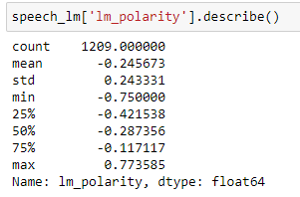

The descriptive statistics suggest:

- Mean: The mean sentiment score is -0.245673, which is somewhat negative, suggesting a general negative sentiment across the dataset.
- Standard Deviation: The standard deviation is relatively high at 0.243331, indicating variability in sentiment across different texts.
- Minimum: The most negative sentiment score is -0.750000, showing that there are texts with a strongly negative sentiment.
- 25th Percentile: A quarter of the data falls below -0.421538, further emphasizing that a significant portion of the dataset contains fairly negative sentiments.
- Median (50th Percentile): The median score is -0.287356, confirming the negative trend observed in the mean.
- 75th Percentile: Three-quarters of the data has a polarity score above -0.117117, indicating that the most negative sentiments are not shared by all texts in the dataset.
- Maximum: The highest sentiment score is 0.773585, revealing that there are also instances of positive sentiment, although these are less frequent given the negative mean score.

FinBERT

The second financial model is FinBERT, specifically we used FinBERTTone as it “achieves superior performance on financial tone analysis task.” Specifically, it is “fine-tuned on 10,000 manually annotated (positive, negative, neutral) sentences from analyst reports.”

Although this quote is admittedly cited from the creator of FinBERT, we were drawn to the claim that “FinBERT substantially outperforms the Loughran and McDonald dictionary and other machine learning algorithms ”

Composition:
FinBERT is formed of two parts:
- The base of the model is Google’s BERT. “BERT is a model for natural language processing developed by Google that learns bi-directional representations of text to significantly improve contextual understanding of unlabeled text across many different tasks…. BERT models have been trained on BookCorpus and English Wikipedia, which have in total more than 3.5 billion words ”
- FinBERT is trained on the following three financial communication corpus. The total corpora size is 4.9B tokens.
- Corporate Reports 10-K & 10-Q: 2.5B tokens
- Earnings Call Transcripts: 1.3B tokens
- Analyst Reports: 1.1B tokens

Approach:
FinBERT uses BERT to present a large language model approach rather than the static lexicon approach Loughran McDonald offers. “Unlike traditional language models that read text in one direction (either left-to-right or right-to-left), BERT considers both directions simultaneously. This bidirectional context allows BERT to capture complex relationships and nuances in language.”

Application:
We used FinBERTtone by following the official documentation on HuggingFace.

Strengths:
- Contextual Awareness: By using Google’s BERT's deep learning architecture, FinBERT can understand the context in which words are used, allowing for more nuanced sentiment analysis that reflects the complexities of financial statements.
- Superior Performance on Financial Tone: The additional fine-tuning on manually annotated sentences from analyst reports means that FinBERT offers even more specialised financial knowledge. This is particularly important given the nature of BOE’s speeches.
- High Accuracy in Negative Sentiment Detection: FinBERT is particularly adept at identifying negative sentiments which, given the tumultuous period of the data provided, could be invaluable. “Further analyses show a distinct advantage in FinBERT's detection of negative sentiments (89.7% accuracy, compared to less than 60% accuracy for non-BERT algorithms), a point worth noting given that negative sentiments have a larger impact on investors than positive ones ”

Weaknesses:
- Computational Resource Requirements: Being a deep learning model, FinBERT requires substantial computational resources for training and inference, which proved difficult to install and time consuming to run.
- Complexity and Opacity: The workings of FinBERT are more complex compared to a dictionary-based approach, making it less transparent in how sentiment scores are derived.
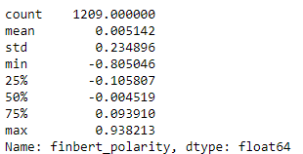

The descriptive statistics suggest:
- Mean: The average sentiment score is very close to zero (0.005142), indicating that overall sentiment across all speeches is almost neutral.
- Standard Deviation: A relatively high standard deviation (0.234896) suggests there's considerable variability in sentiment scores.
- Minimum: The most negative sentiment score is quite low (-0.805046), showing that there have been instances of strongly negative sentiment.
- 25th Percentile: 25% of the scores are lower than -0.105807, which could be considered mildly negative.
- Median (50th Percentile): The median sentiment score is slightly negative (-0.004519), reinforcing the mean's indication of a general tilt towards neutral sentiment.
- 75th Percentile: 75% of the scores are below 0.093910, indicating that more positive sentiments are not as extreme as the negative ones.
- Maximum: The most positive sentiment score is very high (0.938213), showing that there have also been instances of strongly positive sentiment
Table comparison between the financial models:
Name | Base dictionary | Financial dictionary | Approach | Last updated
Loughran-McDonald (lm) | 2of12inf | - EDGAR 10-K archive  - Earnings calls from CapIQ  - Analyst Reports | Dictionary (BOW) | February 2024
FinBERT | Google’s - BERT | - Corporate Reports 10-K & 10-Q: 2.5B tokens  - Earnings Call Transcripts: 1.3B tokens  - Analyst Reports: 1.1B tokens | llm (Large language model) | 2022

The two models perform very similar in comparison to each other as evidenced here by the quarterly time series plot comparing models. This plot is for illustrative purposes, to show lm in orange and FinBERT in red, please view the Notebook for a full navigable image.

Both models show a comparable understanding of change of sentiment within a financial context over time. However, Loughran McDonald shows a generally more negative view and FinBERT’s neutrality here perhaps reflects BERT’s ability to appreciate nuanced context more successfully.
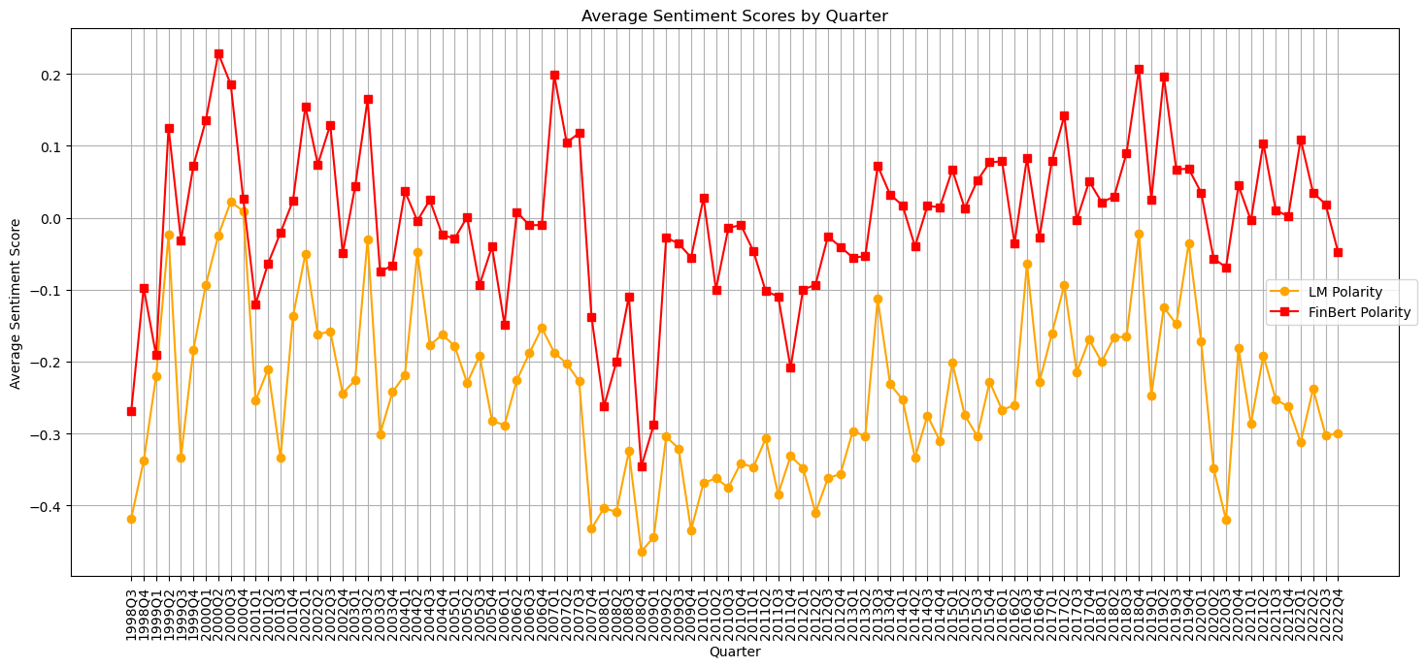

The distribution of sentiment scores goes on to reflect a similar idea, revealing how FinBERT offers a more balanced distribution.

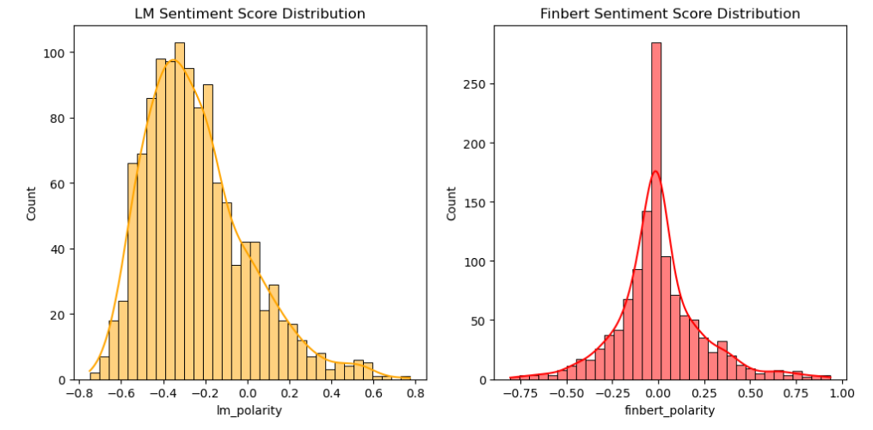
Even though both models perform well, ultimately FinBERT proves to be the more reliable model and will be the choice moving forward. The histogram allows for an immediate visual interpretation of the data. Consider the following reasons:

- Deep Learning Advantage: BERT's architecture for a nuanced understanding of financial language context is the key here, outperforming Loughran McDonald’s static lexicon approach.
- Accuracy in Sentiment Detection: FinBERT proves superior at detecting negative sentiments, essential for Bank of England communications during several economic downturns present in the time period.
- Balanced Sentiment Distribution: FinBERT offers a better distributed view of sentiments, avoiding the skew towards negativity seen with Loughran McDonald , providing what feels like a fairer analysis of speeches.

Comparing all models:
In concluding our findings from the year-by-year and quarterly analyses, along with a detailed review of the sentiment score distributions, FinBERT emerges as the superior model for this speech evaluation.

Unlike the general-purpose models TextBlob and Vader, which either exhibited too narrow a sentiment range or skewed towards extremes, FinBERT demonstrated a capacity for nuanced interpretation closely aligned with the measured tone of Bank of England communications. Loughran McDonald, while closely aligned with financial terminology, still lacked the contextual depth FinBERT provided, allowing it’s polarity to be unusually skewed in the negative.

Let’s compare all model’s average annual sentiment now using a simple time series graph that we’ve used before:

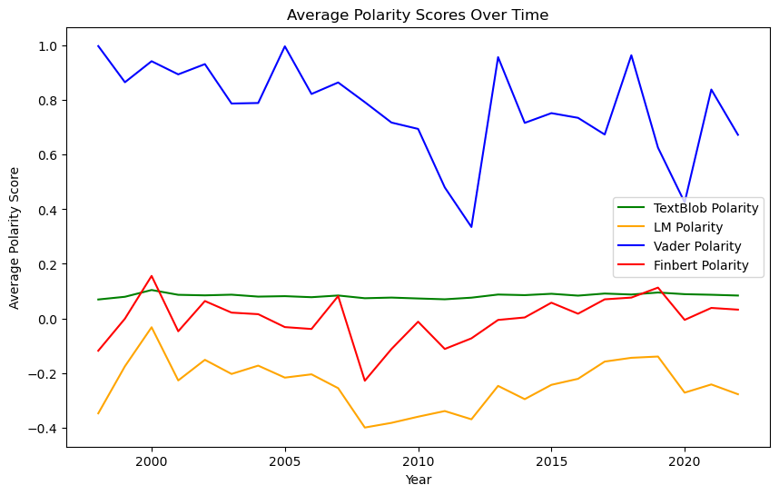

- TextBlob tends toward an unrepresentative neutrality, failing to capture the range of sentiments typically present in financial discourse.

- Vader displays a seemingly binary interpretation of sentiment, which oversimplifies the nuanced language used in financial communications.

- Loughran McDonald and FinBERT exhibit similar trends in sentiment analysis; however, Loughran McDonald’s pronounced negative skew suggests a somewhatlimited understanding of the data, in contrast to FinBERT's more balanced approach.

- FinBERT offers good movement around the expected neutral mark, suggesting that BERT has offered a more balanced interpretation of the speech data.

The average quarterly sentiment scores serves to show us, as above, that FinBERT offers the most balanced and consistent scores. The plot can be viewed in better detail on the Notebook provided. It is here in the report for illustrative purposes.
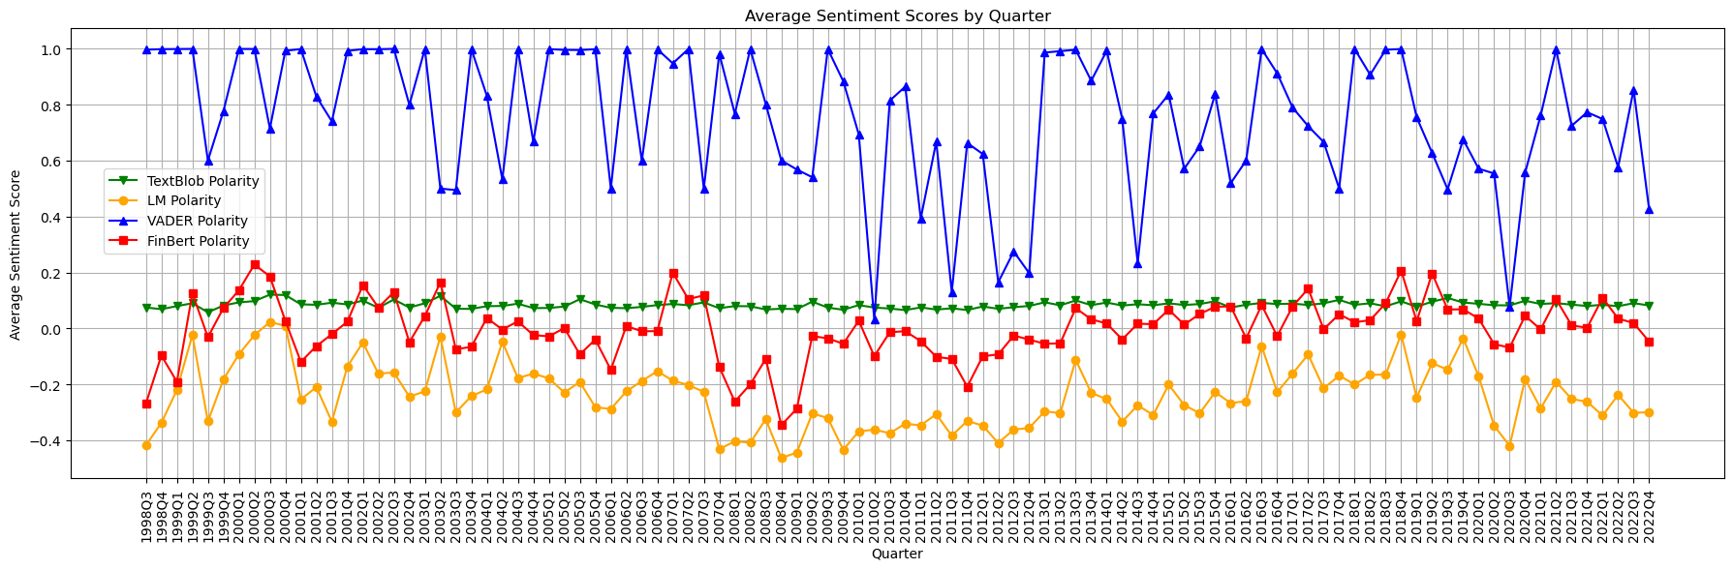

Reflecting on all the model’s distribution with a histogram we can see similar patterns as the time series reveals the spread of the models polarity score nicely.
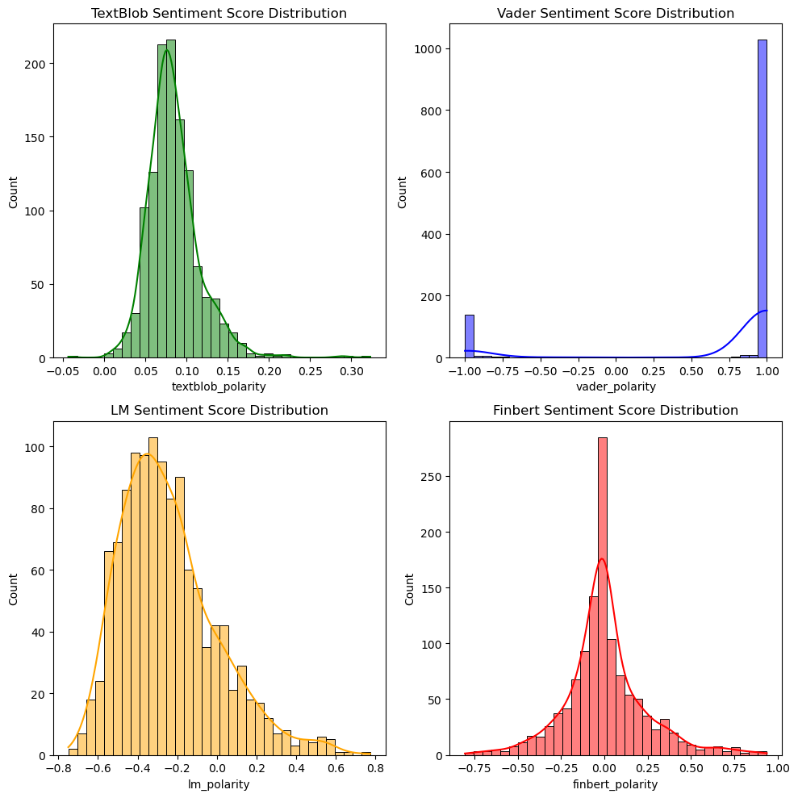
- Vader: seems to categorise sentiment towards extremes, especially towards the positive, which seems unlikely to reflect the typically reserved language of the Bank of England.
- Loughran McDonald: appears to be the normally distributed, which might suggest a better fit for the type of language used in financial documents, but the significant negative skew suggests that it has struggled to make entirely accurate predictions.
- TextBlob: seems to be normally distributed as well but the range of sentiment scores is much too small to be considered useful.
- FinBERT: also appears normally distributed and the sharp peak at zero with symmetrical tails on both sides, indicates that it not only captures neutrality well but also detects variations towards both positive and negative sentiments in a balanced way. Given this, and the above analysis, FinBERT feels like the most appropriate model to continue with.

Feature | TextBlob | VADER | Loughran McDonald(lm) | FinBERT
Base Dictionary(s) | Base:  General English | Base:  General English with social media emphasis | Base:  - PySentiment2  - Financial:  - EDGAR 10-K archive  - CapIQ earnings calls | - Base:  - Google's BERT (BookCorpus and English Wikipedia),  - Financial:  - Corporate Reports 10-K & 10-Q: 2.5B tokens  - Earnings Call Transcripts: 1.3B tokens  - Analyst Reports: 1.1B tokens
Approach | General lexicon (Bag of Words) | General lexicon and rule-based | General lexicon (Bag of Words) with financial focus | Large Language Model (LLOUGHRAN MCDONALD), deep learning with financial focus
Domain Specificity | General | General with a focus on social media | Financial documents | - Financial documents  - Financial texts
Last Updated | N/A (updates vary by library version) | N/A (updates vary by library version) | February 2024 | 2022
Key Strengths | - Simple, transparent and user-friendly  .  - Versatile for general NLP tasks. | - Understands nuances through rule-based analysis. | - Tailored for financial text analysis.  - Transparency in sentiment scoring | - Deep contextual understanding  - High accuracy, especially for negative sentiments  - Deep understanding of financial context.
Key Considerations | - May not capture domain-specific nuances.  - Less accurate for complex sentiments. | - Less effective outside social media contexts.  - Static rules can miss specific speech language trends. | - Limited in capturing complex context.  - Static lexicon may miss specific speech language trends. | - Requires substantial computational resources  - Complexity in model understanding, less transparent.
Ideal Use Case | General sentiment analysis | General sentiment analysis with social media | Financial text analysis focusing on specific and static terminology | In-depth financial sentiment analysis where context and nuanced understanding are crucial

Exploring word frequencies from The Bank of England provided speeches across the models:
In a very simple way plotting frequencies and word clouds allows the bank to consider the business question: Do these speeches have any predictive power to assist in predicting market behaviour?
By sorting and filtering positive and negative words we get an idea of which words cause which sentiment and therefore, the opportunity to tailor communications accordingly. This is true for both speeches and the reports.

Initially the top 20 most positive and most negative speeches were found for every model. This was done by sorting the speeches by their respective polarities and filtering by top 20.

Then sentiment word frequencies were explored for each model by setting thresholds. The positive threshold was set to > 0 and negative at < 0. The thresholds were set according to typical limits of positivity and negativity, with the exception of FinBERT. This threshold however is entirely customisable in the Notebook provided.

Following the threshold filtration, the positively and negatively associated speeches are merged into separate strings, ordered by polarity, the words extracted and their frequencies counted. The words are ranked by frequency to determine the most prevalent in each sentiment category.

Finally, word clouds are generated from the top 30 words in each sentiment pole to visualise the most frequent positive and negative terms. These word clouds provide a graphical representation of the key terms associated with each sentiment in the Bank of England's communications.

Word clouds allow for an immediate visual interpretation of the data and offer useful insights.
Analysis of FinBERT is addressed here and in the notebook as it is our best NLP model.

First we consider the correct positive and negative threshold to apply in order to filter the sort of the data.

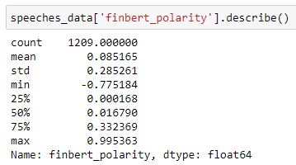

Given the descriptive statistics and the distribution above, it seems correct to set our thresholds around the interquartile range to better capture the more clearly positive or negative sentiments. For instance:

- Negative Threshold: Could be set around the 25% quartile, say at -0, to ensure that only the speeches that are clearly negative are classified as such.
- Positive Threshold: Could be set around the 75% quartile, for example, at 0.30, to classify a speech as positive only if it has a clearly positive sentiment.

Further investigation into FinBERT polarity showed us that, according to the threshold, the total positive speeches was 318 and total negative speeches was 298.

We also discovered that the average length of positive speeches was 1989 words and
the average length of negative speeches was 2343 words

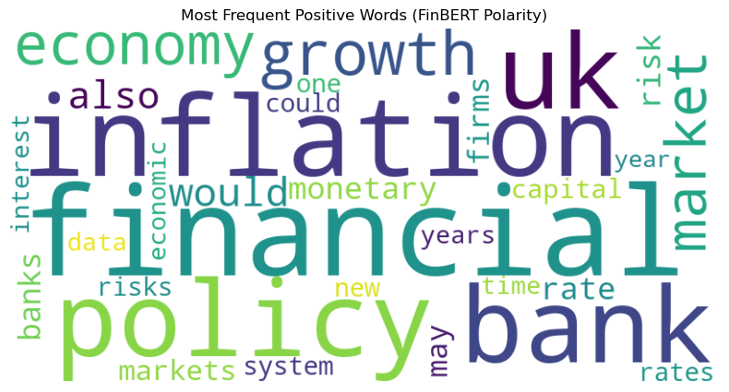
Positive word frequencies: [('financial', 5495), ('inflation', 4407), ('policy', 3962), ('bank', 3947), ('uk', 3879), ('growth', 3547), ('economy', 3128), ('market', 2982), ('would', 2936), ('also', 2704), ('monetary', 2567), ('rate', 2549), ('risk', 2503), ('banks', 2394), ('may', 2322), ('firms', 2299), ('markets', 2195), ('capital', 2182), ('one', 2098), ('rates', 2074), ('new', 2045), ('risks', 2034), ('could', 2020), ('system', 1995), ('interest', 1894), ('years', 1887), ('time', 1856), ('economic', 1830), ('data', 1821), ('year', 1735)]
Positive Sentiment Insights

Unique Positive Words
- Risks (2034): Often discussed in a context that emphasises managing or mitigating financial risks, which might be viewed positively as proactive or cautious.
- Firms (2299): Likely refers to businesses and their activities or performance, which in a positive sentiment could relate to growth, innovation, or contribution to the economy.
- New (2045): Indicates forward-looking or innovative aspects, such as new policies, technologies, or initiatives, seen as beneficial or promising.
- System (1995): Could relate to the financial system or specific systems within banking and finance, suggesting stability, robustness, or efficiency.
- Data (1821): Points to the use of data in making informed decisions or analysis, highlighting transparency, accuracy, or advancement in banking practices.

More frequent positive words (>=500 occurrences compared to negative):
- There weren't any.

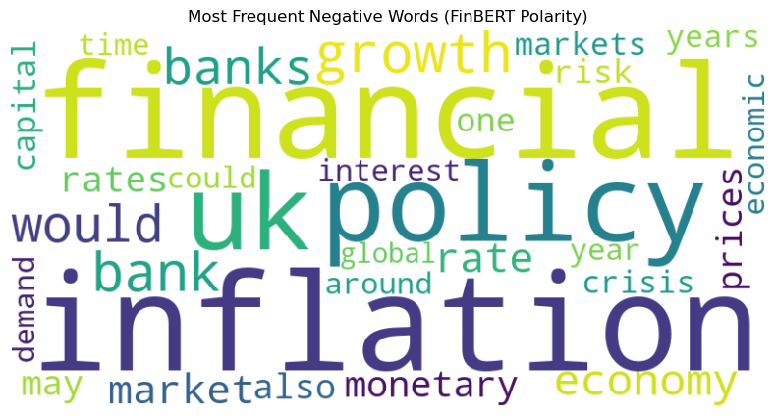

Negative word frequencies: [('inflation', 5438), ('financial', 5071), ('policy', 5061), ('uk', 4884), ('growth', 4630), ('bank', 4538), ('would', 4088), ('banks', 4076), ('economy', 3975), ('rate', 3404), ('market', 3179), ('monetary', 3153), ('rates', 2967), ('may', 2801), ('prices', 2795), ('also', 2790), ('risk', 2474), ('one', 2451), ('capital', 2373), ('crisis', 2245), ('years', 2236), ('markets', 2210), ('interest', 2205), ('could', 2170), ('around', 2107), ('year', 2095), ('time', 2090), ('economic', 2074), ('demand', 2062), ('global', 2026)] ('interest', 1459), ('demand', 1454), ('years', 1451), ('credit', 1424)]
Unique Negative Words
- Prices (2795): Could be associated with inflation or rising costs, leading to negative sentiment regarding economic pressure or living costs.
- Global (2026): Refers to global challenges, crises, or economic conditions that negatively impact the UK or the global economy.
- Crisis (2245): Directly related to financial crises, uncertainties, or significant negative economic events. Which is appropriate given the tumultuous period of the data.
- Demand (2062): In a negative context, could relate to decreasing demand, economic slowdowns, or challenges in meeting demand.
- Around (2107): Usage might be in contexts discussing uncertainties or concerns surrounding various economic factors.

More frequent negative words (>=500) The numbers are the amounts by which these words appear more frequently in the negative section compared to the positive section
- Would (1152): Often used in speculating about negative outcomes or uncertainties, particularly in discussing adverse future scenarios.
- Inflation (1031): Central in discussions about the negative impacts on purchasing power, increased cost of living, and overall economic pressures.
- Policy (1099): Refers to government or monetary policies that may be viewed unfavorably or blamed for adverse economic conditions.
- UK (1005): Concerns specifically impacting the United Kingdom, such as Brexit, economic policies, or national financial challenges.
- Growth (1083): Could be discussed in terms of slowdowns, reduced forecasts, or stagnant conditions that affect economic sentiments negatively.
- Banks (1682): Discussions likely focus on challenges, failures, or issues within the banking institutions.
- Economy (847): Refers to downturns, recessions, or overall negative health of the economy.
- Rates (893): Discusses the broader implications of changes in interest rates on mortgages, loans, and economic growth.
- Rate (855): Involves interest rates, particularly increases which may suggest tightening monetary policy or concerns about inflation.
- Bank (591): Focuses on specific problems associated with banks or the banking sector as a whole.
- Monetary (586): Involves discussions on monetary policy that in a negative context could relate to criticisms or constraints of current policy measures.

Recommendations:
Positive Sentiment Triggers
- Proactivity and Management: Words like "risks," "system," and "data" are associated with proactive management and positive actions. These suggest efforts to ensure stability and thoughtful, informed decision-making.
- Innovation and Progress: Terms such as "new" and "firms" highlight forward-thinking, innovation, and positive contributions to the economy. They evoke a sense of progress and development.
Negative Sentiment Triggers
- Economic Challenges: Words like "inflation," "crisis," and "rates" often appear in contexts discussing economic pressures and challenges, which naturally tend to generate negative sentiments.
- Speculative and Uncertain Language: Use of words like "would" and "could" can introduce uncertainty and speculation, often associated with less positive or anxious sentiments.
- Banking and Policy Concerns: Terms such as "banks," "policy," and "monetary" can evoke negative sentiments when linked to problems or criticisms of banking practices and economic policies.

Final observation:

- Addressing Sentiment Imbalance: The lesser frequency of positive terms suggests a potential negative skew in communication. Increasing the use of positive words can help foster a more optimistic public perception, balancing the narrative around economic conditions.

Exploring the use of FinBERT and word frequencies on FSR and MPC reports:
We now have a justifiable analytical framework and NLP model that can be used to find correlation between sentiment scores and indicators over time.
In relation to the business questions provided, the data shows us that there are not many significant correlations between Bank of England speeches from 1999 – 2022 and economic indicators. Instead, we see a level of neutrality in sentiment scores over time consistent with a central bank’s expected communication style. When polarity does shift significantly, this is in reaction and acknowledgement to world events substantial enough to force the Bank from its intended neutral position and into a more positive or negative sentiment.
In spite of this, the analytical approach still remains useful and have applications beyond the business questions provided. For instance, you could apply the same techniques to other central banks to compare communication styles and any potential economic correlations as a result. However, as we have seen, speeches can lack specificity:
- Addressing countries other than the UK (19/03/2002 “Asian Business Association Dinner” by George
- Focused on the future (02/03/2018, “The Future of Money” by Carney
- Or the past (03/06/2001, “The Beveridge Curve, Unemployment and Wages in the OECD from the 1960s to the 1990s” by Nickell)
These are exampling all elements that could skew polarity scores of the relative present in the UK.
This led us to consider Bank of England communications other than speeches, communications like the FSR or MPC reports, which are necessarily geographically constrained to the UK and economically constrained to current relevant justifications. In particular the MPC explains The Bank’s decisions of its main measure of control, the setting of interest rates.
These more localised and time-specific sources may offer a clearer reflection of the Bank's policy decisions and their impact on economic indicators. Through this, we potentially refine our understanding of the relationship between central bank discourse, sentiment, and economic health.

What are the MPC and FSR?
The Monetary Policy Report
The Monetary Policy Report sets out the economic analysis and inflation projections that the Monetary Policy Committee uses to make its interest rate decisions. Previously called the inflation report, which first published in February 1993, with the objective “to produce a wholly objective and comprehensive analysis of inflationary trends and pressures”.
Typically, of the form:
1: The economic outlook, including underlying conditions and assumptions
2: Current global and domestic economic conditions, with varying items of focus, such as Wage growth and inflation, Inflation expectations
Published by the bank of England, quarterly since Nov 2019 . Feb, Nov, May, Aug. and previously on the same schedule as the “Inflation Report” since February 1993.
The Financial Stability Report
Financial Stability report. First published in October 1996 as the Financial Stability Review, this was renamed in 2006 to the Financial Stability Report to reflect the change in content and aims.
The Financial Stability Report sets out the Financial Policy Committee's view on the stability of the UK financial system and what it is doing to remove or reduce any risks to it.
Form varies considerably over time – initially quite a lot of the reports appear to be qualitative, but more recently there is a great degree of transparency, with attached data files.
It is published twice a year, generally in July and December.

Exploring the reports in python: analytics and word clouds
We imported and cleaned the data to the appropriate extent that FinBERT requires, namely:
- Ensure text is in English : We have tagged each speech for their language.
- Handle missing values: There weren't any
- Standardise text data : FinBERT works well if the text is standardised (i.e. ensure consistent use of quotation marks etc). We will take the assumption that the use of quotation marks etc has been applied consistently.
- Remove unnecessary elements: It is good practice to remove URLs and other specific mark ups. However, in the same vein, it is important not to over clean.
- Ensure Data is in a Suitable Format: The data is contained in a dataframe column.
Then we run the normal sentiment analysis, which can be followed as before in the notebook.
The decision was made to not merge the two dataframe’s in any way. By avoiding joining/concatenation, we prevent the presence of NaNs and the subsequent need to address them. By conducting NLP analysis individually for each dataset, we maintain efficiency while retaining the option to combine the scores into one DataFrame at the end should we need to.
Let us now consider the word cloud out put from the models.

Financial Stability Report:
First we consider the correct positive and negative threshold to apply in order to filter the sort the data. The process is the same as it was for the main body of speeches so will not be detailed here again.

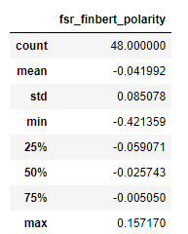
- Average length of positive FSR reports: 63910.72 words
- Average length of negative FSR reports: 56645.51 words
- Total number of positive FSR reports: 36
- Total number of negative FSR reports: 39

Given the descriptive statistics and the distribution above, it seems correct to set our thresholds around the interquartile range to better capture the more clearly positive or negative sentiments. For instance:
- Negative Threshold: Could be set around the 25% quartile, say at -0.059, to ensure that only the speeches that are clearly negative are classified as such.
- Positive Threshold: Could be set around the 75% quartile, for example, at 0, to classify a speech as positive only if it has a clearly positive sentiment.
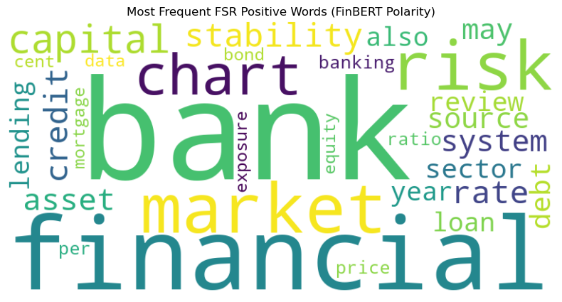
[('bank', 31499), ('financial', 19218), ('market', 14202), ('risk', 14033), ('chart', 9338), ('capital', 8500), ('stability', 8296), ('rate', 7842), ('credit', 7788), ('asset', 7059), ('system', 6791), ('source', 6140), ('may', 6045), ('debt', 5636), ('sector', 5481), ('review', 5298), ('loan', 5040), ('also', 5034), ('lending', 5009), ('year', 4957), ('banking', 4776), ('price', 4697), ('ratio', 4541), ('per', 4427), ('exposure', 4254), ('data', 4103), ('equity', 4080), ('bond', 4070), ('cent', 4018), ('mortgage', 4007)]

Unique Words:
- Per (4,427): Likely used in contexts discussing percentages or specific measurements, which may carry a neutral or slightly positive connotation.
- Cent (4,018): Similar to "per," often part of financial data presentation, implying stability or precise information.

More Frequent Words:
- Financial (13,998): Central to FSR, often associated with stability and positive developments.
- Risk (848): Surprisingly, appears more in positive contexts, possibly discussed in terms of risk management or mitigation successes.
- Stability (949): Directly correlates with the core aims of financial oversight and assurance.
- System (577): References to systemic aspects of banking, suggesting discussions on robustness and reliability.
- May (526): Indicates speculative or potential positive outcomes or scenarios.
- Review (1,210): Implicates thorough examination and control processes, reassuring stakeholders.

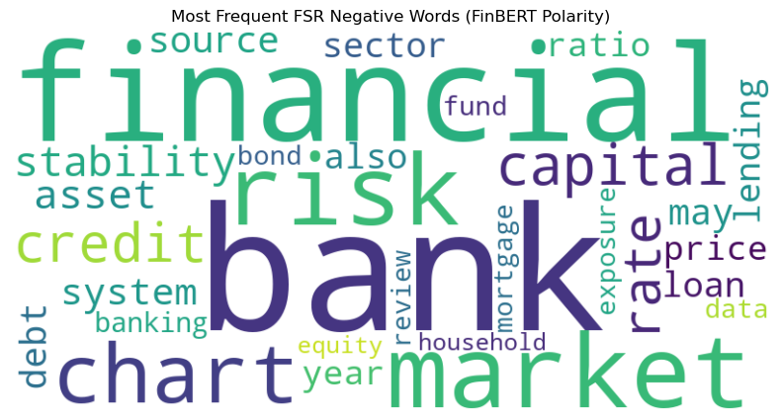
[('bank', 31202), ('financial', 17820), ('market', 14267), ('risk', 13185), ('chart', 8854), ('capital', 8677), ('credit', 7806), ('rate', 7526), ('stability', 7347), ('asset', 7168), ('system', 6214), ('source', 5807), ('may', 5519), ('debt', 5389), ('sector', 4996), ('lending', 4913), ('loan', 4878), ('also', 4872), ('price', 4677), ('ratio', 4605), ('year', 4529), ('banking', 4521), ('mortgage', 4168), ('data', 4153), ('fund', 4124), ('review', 4088), ('bond', 4013), ('exposure', 3961), ('household', 3890), ('equity', 3885)]

Unique Words:
- Fund (4,124): May relate to specific financial instruments or reserves, possibly discussed in contexts of insufficiency or stress.
- Household (3,890): Typically associated with vulnerabilities or stress in consumer finance segments.
Insights on Sentiment Themes
Positive Insights:
- Emphasise further analysis and discussions on financial stability, risk management strategies, and systematic strengths to maintain positive sentiments.
Negative Insights:
- Address issues related to funds management and household financial stability to alleviate negative sentiments.

The Monetary Policy Report:
First we consider the correct positive and negative threshold to apply in order to filter the sort the data. The process is the same as it was for the main body of speeches so will not be detailed here again.

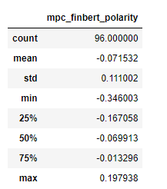
- Average length of positive reports: 36842.00 words
- Average length of negative reports: 33596.95 words
- Total number of positive reports: 20
- Total number of negative reports: 22

Given the descriptive statistics and the distribution above, it seems correct to set our thresholds around the interquartile range to better capture the more clearly positive or negative sentiments. For instance:
- Negative Threshold: Could be set around the 25% quartile, say at -0.17, to ensure that only the speeches that are clearly negative are classified as such.
- Positive Threshold: Could be set around the 75% quartile, for example, at 0, to classify a speech as positive only if it has a clearly positive sentiment.
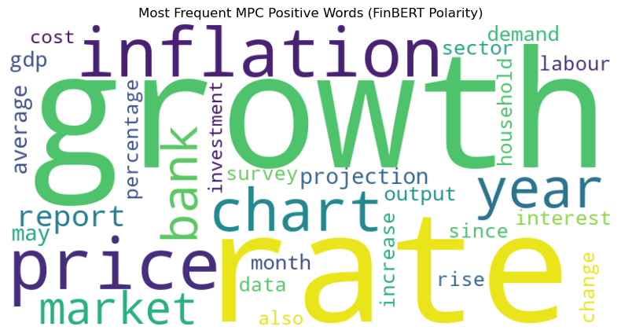
[('growth', 7173), ('rate', 6456), ('price', 6353), ('inflation', 6193), ('chart', 4401), ('year', 3777), ('bank', 3069), ('market', 2892), ('report', 2722), ('projection', 2449), ('may', 2372), ('average', 2347), ('gdp', 2227), ('demand', 2146), ('sector', 2078), ('interest', 2049), ('month', 2031), ('output', 1994), ('percentage', 1904), ('since', 1883), ('change', 1882), ('survey', 1828), ('household', 1817), ('data', 1786), ('labour', 1747), ('increase', 1744), ('rise', 1741), ('investment', 1664), ('also', 1611), ('cost', 1560)]
Unique Words
- Interest (2049): Likely associated with positive financial outcomes or rewarding investment returns.
- Investment (1664): Suggests forward-looking, growth-oriented financial activities.
- Rise (1741): Typically refers to growth in economic indicators like prices or rates, perceived positively..
More Frequent Words
- Growth (7173): Reflects economic expansion, often seen as a primary indicator of healthy economic conditions.
- Rate (6456): Can be tied to interest rates, where a favorable rate is indicative of good economic management.
- Price (6353): In a positive context, may indicate stability or reasonable inflation levels.
- Year (3777): Often used in discussions of annual progress or achievements.
- Interest (2049): Also appears as a unique word; its frequency underlines its importance in financial discussions.
- Rise (1741): As a more frequent word, it underscores positive growth trends.
- Investment (1664): Emphasizes proactive financial strategies and economic optimism.

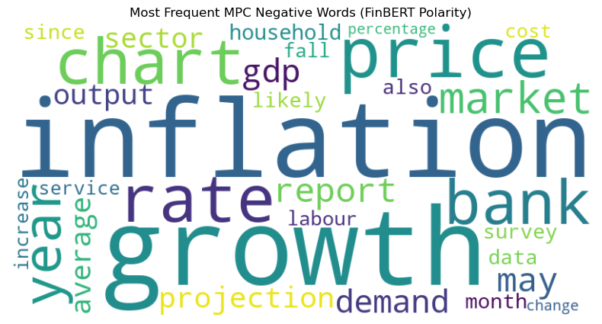
[('inflation', 5862), ('growth', 5850), ('price', 5804), ('rate', 4978), ('chart', 4634), ('bank', 4425), ('year', 3147), ('market', 2804), ('report', 2656), ('may', 2488), ('gdp', 2431), ('demand', 2357), ('projection', 2180), ('average', 2125), ('output', 2106), ('sector', 2033), ('household', 2019), ('survey', 1928), ('data', 1904), ('also', 1873), ('likely', 1872), ('since', 1830), ('month', 1826), ('labour', 1711), ('fall', 1707), ('service', 1593), ('cost', 1582), ('increase', 1576), ('percentage', 1564), ('change', 1526)]
Negative Section
Unique Words
- Fall (1707): Often associated with declines in economic indicators, viewed negatively.
- Likely (1872): In negative contexts, may refer to the probable occurrence of undesirable events.
- Service (1593): Can imply issues in service industries or burdens caused by service sector problems.
More Frequent Words
- Bank (4425): In negative contexts, could be associated with failures, bailouts, or crises.
- Likely (1872): Reflects the anticipation or risk of negative developments.
- Fall (1707): Reinforces concerns about economic downturns or falling markets.
- Service (1593): If frequent in negative contexts, may highlight systemic issues within service-oriented sectors.

Insights on Sentiment Themes

Positive Economic Activity
- Positive sentiment in the Bank of England's MPC reports is often linked to terms that convey economic strength and forward-looking optimism. Words like "growth," "investment," and "rise" reflect a focus on economic expansion and robust financial health. These terms are not only frequent but convey a narrative of proactive financial management and the anticipation of favorable economic outcomes.
Economic Challenges and Risks
- Negative sentiment revolves around terms associated with economic setbacks or uncertainties. "Fall," "bank," and "likely" frequently appear in contexts that discuss declines, potential financial instability, or adverse economic conditions. These words highlight areas of concern within the economy, focusing on risks and the potential for negative outcomes, which could influence public and investor perceptions negatively.

Further consideration for Loughran McDonald implementation
There were questions and complexities that arose during our consideration of Loughran McDonald, specifically how best to implement it. Do we add the words to the Vader/ TextBlob NLP model’s lexicons, do we replace them or do we use it as a standalone model?

FinBERT is too complex and inaccessible a model to fuse Loughran McDonald to, and fusing Loughran McDonald to TextBlob does not offer any chance for adding dimensionality through Vader’s better context appreciation. Therefore, we will be exploring pairing Loughran McDonald with Vader.

Initially, adding to VADER’s existing lexicon with Loughran-McDonald feels more appropriate than replacing it because, for the most part, they could enrich each other. Loughran McDonald’s domain specific lexicon should serve to increase the accuracy and relevance of VADER’s already comprehensive lexicon.

However, there are several issues why introducing the Loughran McDonald lexicon to VADER‘s lexicon isn’t straightforward:

First:
- VADER is designed primarily for social media texts, focusing on the polarity of sentiment (positive, negative, neutral). It assigns a single score to words/phrases based on their perceived sentiment in general usage.
- Loughran-McDonald is specialised for financial texts, using multiple specific dimensions beyond the simple polarity of VADER: Negative, Positive, Uncertainty, Litigious, Strong, Weak, and Constraining. These categories reflect the nuanced way words can convey sentiment in financial contexts.
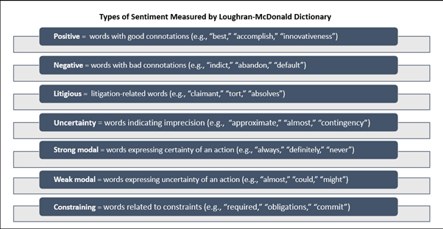
Second:
- It is technically possible to adjust these extra dimensions of Loughran McDonald to suit the VADER model but this is a complex and time-consuming activity. Consider the following arbitrary numbers that attempt to map Loughran McDonald’s polarity scale onto Vader:

- Positive: +1.0 (top end of the spectrum)
- Strong: +0.5
- Litigious: 0 (may not significantly affect general sentiment unless in specific contexts)
- Constraining: -0.25 (assuming a slight negative sentiment)
- Uncertainty: -0.25 (assuming a slight negative sentiment)
- Weak: -0.5
- Negative: -1.0 (bottom end of the spectrum)

- While possible, you immediately lose out on the subtlety those dimensions created. For instance, how do you decide on the scores between Constraining and Uncertainty?
- You also lose sight of the fact that Uncertainty, Litigious, Strong, Weak, and Constraining are all modifiers as well. They exist both as independent categories but also additional scores to the baseline of Positive or Negative in order to enhance interpretation.
- For instance, ENCUMBER has several categories.

Third:
- Context is important and there may be a mismatch of VADER’s interpretation of words against Loughran McDonald’s.
- For instance, consider the word “Suggest”
- From a VADER perspective that could be a simple neutral verb
- From a Loughran McDonald perspective however, “Suggest” means Uncertainty and Weakness

Given these considerations, operating Loughran McDonald as a standalone model emerges as the most effective approach. This method preserves the lexicon's financial domain specificity and avoids the compromises involved in integration. To facilitate this, we employ PySentiment2, allowing for a direct incorporation of Loughran McDonald's lexicon into our analysis framework.

Bibliography:

Arjun (2024) Deploy and host a financial Bert model as API in AWS sagemaker, Medium. Available at: https://medium.com/@viswanathan.arjun/deploy-and-host-a-financial-bert-model-as-api-in-aws-sagemaker-7b381dfbcd6a (Accessed: 01 April 2024).

Cjhutto (2014) CJHUTTO/Vadersentiment: Vader sentiment analysis. GitHub. Available at: https://github.com/cjhutto/vaderSentiment (Accessed: 04 April 2024).

Huang, Allen H., Hui Wang, and Yi Yang. "FinBERT: A Large Language Model for Extracting Information from Financial Text." Contemporary Accounting Research (2022).

Huang, A. (2022) (PDF) FinBERT: A large language model for extracting information ..., Researchgate. Available at: https://www.researchgate.net/publication/364070191_FinBERT_A_Large_Language_Model_for_Extracting_Information_from_Financial_Text (Accessed: 01 April 2024).

Marketing Communications: Web // University of Notre Dame (no date) Loughran-McDonald master Dictionary W/ sentiment word lists // software repository for accounting and Finance // University of Notre Dame, Software Repository for Accounting and Finance. Available at: https://sraf.nd.edu/loughranmcdonald-master-dictionary/ (Accessed: 01 April 2024).

Purohit, P. (2021b) Financial sentiment analysis using FinBert, LinkedIn. Available at: https://www.linkedin.com/pulse/financial-sentiment-analysis-using-finbert-praveen-purohit (Accessed: 01 April 2024).

PYSENTIMENT2 (no date) PyPI. Available at: https://pypi.org/project/pysentiment2/ (Accessed: 05 April 2024).

Services, W.R.D. (no date) SEC filings dictionary-based sentiment analysis, WRDS. Available at: https://wrds-www.wharton.upenn.edu/pages/classroom/sec-filings-dictionary-based-sentiment-analysis/#:~:text=Introduction%20to%20the%20Loughran%2DMcDonald,the%20strength%20of%20the%20sentiment. (Accessed: 04 April 2024).

Using NLP news signals to forecast volatility and generate positive returns (no date) Alexandria Technology. Available at: https://www.alexandriatechnology.com/blog/comparing-natural-language-processing-nlp-approaches-for-earnings-calls (Accessed: 01 April 2024).

yiyanghkust/Finbert-tone, no date. Hugging Face. Available at: https://huggingface.co/yiyanghkust/FinBERT-tone (Accessed: 01 April 2024).

Simplified text processing (no date) TextBlob. Available at: https://textblob.readthedocs.io/en/dev/ (Accessed: 04 April 2024).

McMahon , M. and Naylor, M. (no date) Getting through: Communicating Complex Information, The Bank of England. Available at: https://www.bankofengland.co.uk/-/media/boe/files/working-paper/2023/getting-through-communicating-complex-information.pdf (Accessed: 12 April 2024).

SALEHEEN, J. (no date) Central banks need to be clearer on communication, Central Banks need to be clearer on communication. Available at: https://www.ft.com/content/1ed0c4e7-5868-41dd-9165-302266c6e8c8 (Accessed: 12 April 2024).
O.A. et al. (2023) Central Banks’ communication strategy and its impact on the Financial Markets: A Comparison of the Bank of England, the US Federal Reserve and the European Central Bank -, -. Available at: https://esthinktank.com/2023/08/18/central-banks-communication-strategy-and-its-impact-on-the-financial-markets-a-comparison-of-the-bank-of-england-the-us-federal-reserve-and-the-european-central-bank/ (Accessed: 14 April 2024).

McMahon , M. and Naylor, M. (no date) Getting through: Communicating Complex Information, The Bank of England. Available at: https://www.bankofengland.co.uk/-/media/boe/files/working-paper/2023/getting-through-communicating-complex-information.pdf (Accessed: 12 April 2024).
18, O.A. et al. (2023) Central Banks’ communication strategy and its impact on the Financial Markets: A Comparison of the Bank of England, the US Federal Reserve and the European Central Bank -, -. Available at: https://esthinktank.com/2023/08/18/central-banks-communication-strategy-and-its-impact-on-the-financial-markets-a-comparison-of-the-bank-of-england-the-us-federal-reserve-and-the-european-central-bank/ (Accessed: 14 April 2024).
Simplified text processing¶ (no date) TextBlob. Available at: https://textblob.readthedocs.io/en/dev/ (Accessed: 04 April 2024).
Cjhutto (2014) CJHUTTO/Vadersentiment: Vader sentiment analysis. GitHub. Available at: https://github.com/cjhutto/vaderSentiment (Accessed: 04 April 2024).
Services, W.R.D. (no date) SEC filings dictionary-based sentiment analysis, WRDS. Available at: https://wrds-www.wharton.upenn.edu/pages/classroom/sec-filings-dictionary-based-sentiment-analysis/#:~:text=Introduction%20to%20the%20Loughran%2DMcDonald,the%20strength%20of%20the%20sentiment. (Accessed: 04 April 2024).
yiyanghkust/Finbert-tone, no date. Hugging Face. Available at: https://huggingface.co/yiyanghkust/FinBERT-tone (Accessed: 01 April 2024).
Marketing Communications: Web // University of Notre Dame (no date) Loughran-McDonald master Dictionary W/ sentiment word lists // software repository for accounting and Finance // University of Notre Dame, Software Repository for Accounting and Finance. Available at: https://sraf.nd.edu/loughranmcdonald-master-dictionary/ (Accessed: 01 April 2024).
Ibid.
Using NLP news signals to forecast volatility and generate positive returns (no date) Alexandria Technology. Available at: https://www.alexandriatechnology.com/blog/comparing-natural-language-processing-nlp-approaches-for-earnings-calls (Accessed: 01 April 2024).
Huang, Allen H., Hui Wang, and Yi Yang. "FinBERT: A Large Language Model for Extracting Information from Financial Text." Contemporary Accounting Research (2022).
Yiyanghkust/Finbert-tone · hugging face (no date) yiyanghkust/finbert-tone · Hugging Face. Available at: https://huggingface.co/yiyanghkust/FinBERT-tone (Accessed: 01 April 2024).
Huang, A. (2022) (PDF) FinBERT: A large language model for extracting information ..., Researchgate. Available at: https://www.researchgate.net/publication/364070191_FinBERT_A_Large_Language_Model_for_Extracting_Information_from_Financial_Text (Accessed: 01 April 2024) .
Purohit, P. (2021b) Financial sentiment analysis using FinBert, LinkedIn. Available at: https://www.linkedin.com/pulse/financial-sentiment-analysis-using-finbert-praveen-purohit (Accessed: 01 April 2024) .
Yiyanghkust/Finbert-tone · hugging face (no date) yiyanghkust/finbert-tone · Hugging Face. Available at: https://huggingface.co/yiyanghkust/FinBERT-tone (Accessed: 01 April 2024).
Arjun (2024) Deploy and host a financial Bert model as API in AWS sagemaker, Medium. Available at: https://medium.com/@viswanathan.arjun/deploy-and-host-a-financial-bert-model-as-api-in-aws-sagemaker-7b381dfbcd6a (Accessed: 01 April 2024).
Huang, Allen H., Hui Wang, and Yi Yang. "FinBERT: A Large Language Model for Extracting Information from Financial Text." Contemporary Accounting Research (2022).
Services, W.R.D. (no date) SEC filings dictionary-based sentiment analysis, WRDS. Available at: https://wrds-www.wharton.upenn.edu/pages/classroom/sec-filings-dictionary-based-sentiment-analysis/#:~:text=Introduction%20to%20the%20Loughran%2DMcDonald,the%20strength%20of%20the%20sentiment. (Accessed: 04 April 2024).

